**JavaScript Exercise Book**

**CREATING A SCRIPT**

Creating a HTML File that has the following JavaScript code nested within a **<script>** tag

**alert(“Hello World!”);**

Open the HTML file in a browser, it should present a modal dialog with **“Hello World”** inside of it.

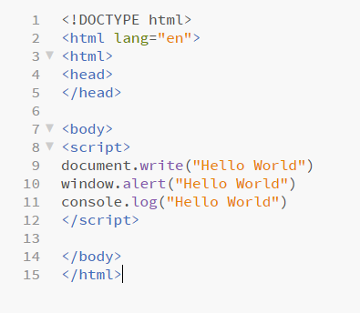

**VARIABLES**

Create a variable using the **var** keyword, store a value in it.

Output the contents of that variable using three different methods

**alert()**

***console*.log()**

***document*.write()**

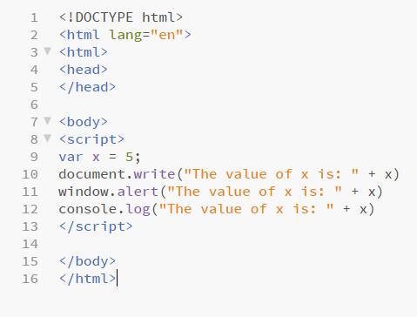

**FUNCTIONS 1**

Create a function that accepts a number and **returns** its square

**Input-> 2 Output -> 4**

Call your function and output your result via one of the three methods.

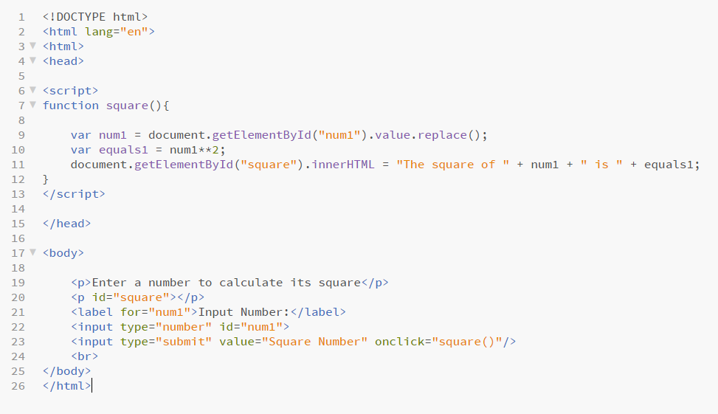

**FUNCTIONS 2**

Create a function that accepts 3 numbers and returns the sum of them

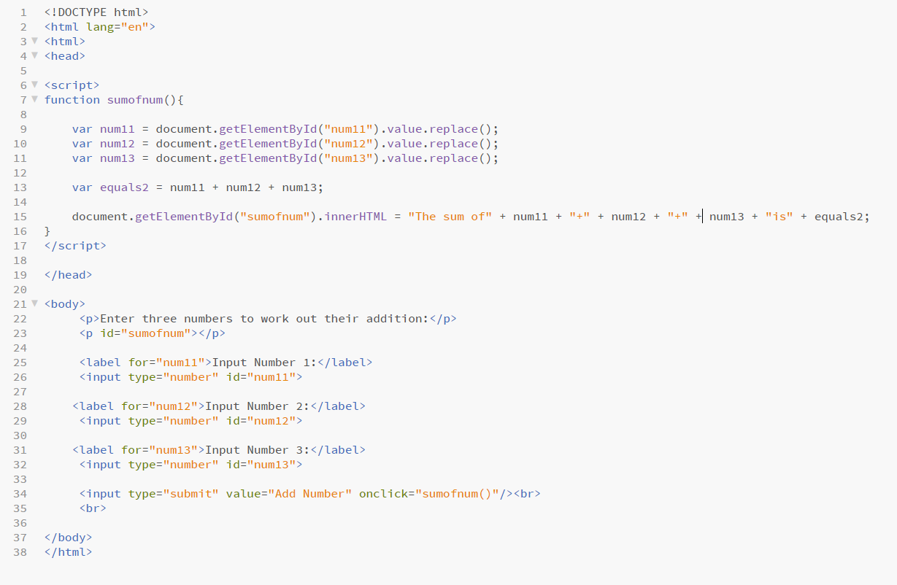**Input-> 1,2,3 Output->6**